Embassy Theatre Skegness | Magna Vitae Productions:
PRODUCTION | Robyn Hood 2026
TEAM
Name

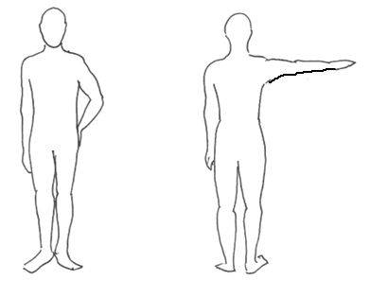
10
6
7
5
9
8
11
3
4
2
1
1 | CHEST/BUST |  |  | 9 | WAIST TO FLOOR
2 | UNDER BUST |  |  | 10 | NAPE TO FLOOR
3 | WAIST |  |  | 11 | UNDERARM
4 | HIPS |  |  |  | HEIGHT
5 | INSIDE LEG |  |  |  | SHOE SIZE
6 | HEAD |  |  |  | UK DRESS SIZE
7 | COLLAR |  |  |  | TROUSER SIZE
8 | NAPE TO WAIST |  |  |  | BRA SIZE

Please provide all appropriate sizes in cms
Costume Notes: -

